Scanning Networks

* IP-Tool for detect live hosts, PC names, open port

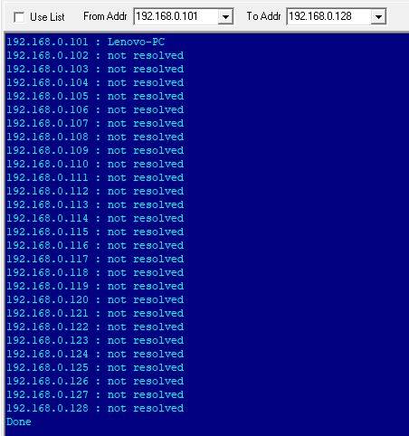

* Angry IP scanner for host name, MAC address, live hosts

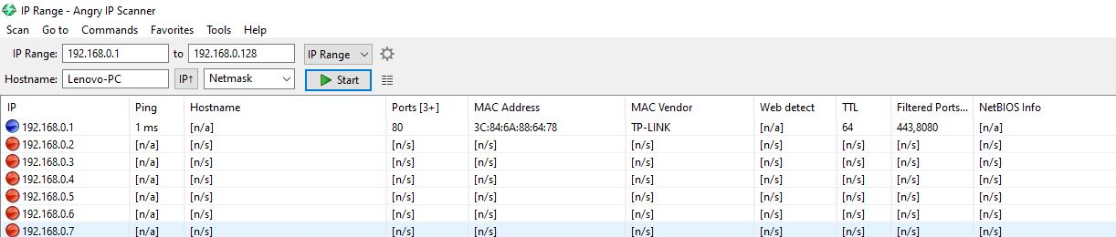

* nmap

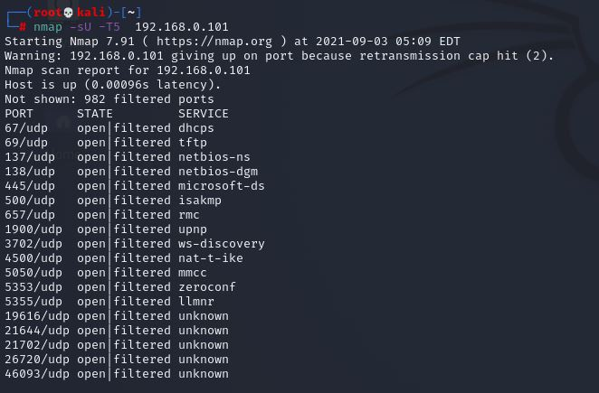

* Tracert for finding path of packet from source to destination

